Rascal Requirements Verification Document

Saint Louis University

Rascal

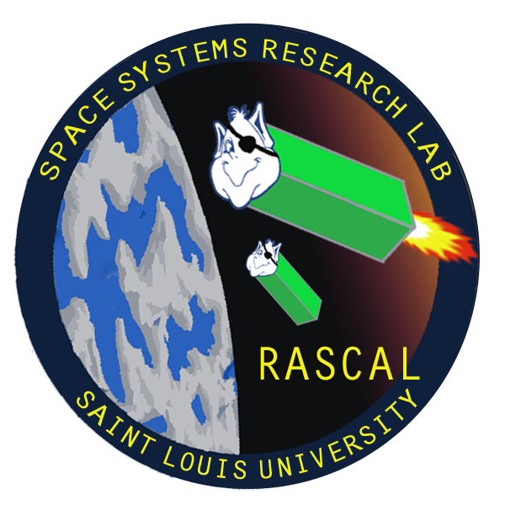

Last Updated: 11/11/13

Document No: RCL-O-CMQA1

Copper Operational

Test Plan

|  |  |  |  |
| --- | --- | --- | --- |
| **Team Member** | **Position** | **Email** | **Phone** |
| Tom Moline | Program Manager/Navigation Engineer | [tmoline@slu.edu](mailto:tmoline@slu.edu) | 630-401-0791 |
| Nate Richard | Propulsion Team | [nrichar8@slu.edu](mailto:nrichar8@slu.edu) | 608-732-7147 |
| Tyler Olson | Structures Team | [tolson6@slu.edu](mailto:tolson6@slu.edu) | 812-204-1098 |
| Bryant Gaume | Propulsion Team | [gbryant1@slu.edu](mailto:gbryant1@slu.edu) | 636-448-0378 |
| Jennifer Babb | Propulsion Team | [jbabb1@slu.edu](mailto:jbabb1@slu.edu) | 636-579-6816 |

**Revisions Summary**

|  |  |  |  |  |
| --- | --- | --- | --- | --- |
| **Revision** | **Description** | **Date** | **Prepared by** | **Approved by** |
| **-** | Description | 11/11/2013 | Tom Moline | Tyler Olson |
|  |  |  |  |  |
|  |  |  |  |  |
|  |  |  |  |  |
|  |  |  |  |  |
|  |  |  |  |  |

# INTRODUCTION

The Rascal Requirements Verification Document serves to define and elaborate on each of the requirements laid out in the RCL-RVM-CMQA1 Rascal Requirements Verification Matrix (RVM), as well as the ways in which each of said requirements will be validated prior to and during the Rascal mission.

The Rascal Mission, as defined by the RVM, can be broken down into Six Stages, with each stage having a set of requirements directly associated with it. Within the requirements associated with each of these stages are sub-requirements associated with a particular subsystem of the Rascal CubeSat system. The manner in which each of these requirements is associated with a particular stage or subsystem is with a simple notation scheme, as shown in Table 1.

**Table 1. RVM Requirement Notation**

|  |  |  |  |
| --- | --- | --- | --- |
| **Mission Identifier** | **Stage Identifier** | **Sub-System Identifier** | **Requirement Number** |
| RCL | Pre Launch (PL) | Structures (STR) | Number In Order of Importance (1 = Highest) |
| Post Launch Ejection (PLE) | Thermal (THM) |
| Separation and Stabilization (SS) | Propulsion (PRP) |
| Stationkeeping (SK) | Testing (TST) |
| “Escape” (ESC) | Mission Operations (MOP) |
| Rendezvous (RDZ) | Payload (PLD) |
| **Example** | **RCL.PL.STR1 (1st Pre-Launch Structures Requirement)** | | |

Furthermore, there are characteristics associated with each of these requirements that help define their origin, usefulness, and validation methods. The most common terms associated with each of these characteristics, as well as their definitions, are listed in Table 2. For each requirement listed in Sections 1-6, one or more of these characteristics will be associated with successfully meeting it.

**Table 2. RVM Requirement Characteristics**

| **Characteristic Type** | **Characteristic Name** | **Characteristic Definition** |
| --- | --- | --- |
| **Relevant Document** | CubeSat Design Specification, Rev 12 | Standard CubeSat Specification Document that Almost Every United States CubeSat Mission has Abided By. Allows for Launch Integration with a P-POD, the Most Widely Used CubeSat Deployer Currently being Manufactured |
| Rascal Request for Proposal | Document that Defines the Rascal Mission, as Well as All of the Requirements that any Design meant to Meet that Mission Must Satisfy |
| Environmental Testing Requirements | Though not Directly Related with Meeting Mission Requirements, as Laid out in the CSD Document or Rascal RFP, These Requirements Offer Much Needed Assurance of Design Durability, Functionality, and Safety, thus Facilitating the Ultimate Goal of Meeting all Mission Requirements |
| SSRL Requirement | Requirements that Facilitate the Operation and Completion of the Rascal Mission at the Space Systems Research Lab, Including Ground Station Capabilities, Past Mission Experience, Personnel Resources, and Cost Limitations |
| Orbital Analysis/Flight Heritage | Requirements that Relate to Preliminary Analyses of the Orbital Mechanics Associated with the Rascal Mission, as well as Understandings of the Past Experiences of Programs that Have Attempted to Perform Proximity Operations on Small Spacecraft |
| **Validation Method** | Examine | Requirements that Involve Measurement (Such as Lengths, Weights, Etc.) or Visual Inspection (Such as Deployer Contact, Inhibit Locations, Etc.) to Validate Successfully Meeting Them |
| Analyze | Requirements that Involve Calculations (Such as CG Locations, Relative Displacement Values, Etc) or, in the case of Mission Operations Requirements, Ground Processing in Order to Validate Successfully Meeting Them |
| Test | Requirements that Involve Environmental Testing (Vibration, Thermal Cycling, Bakeout) in Order to Verify Successfully Meeting Them |
| Demo | Requirements that Involve Demonstration (Such as Deployables Deployment, Separation, RF Inhibit Success, etc.) In Order to Verify Successfully Meeting Them |

Ultimately, the goal of this document is to provide a specific rubric from which to develop the Rascal mission such that it meets all of the design constraints and mission success criteria laid out in the RCL-P-CMQA2 Rascal Request for Proposal document. Thus, if the designed mission meets all of the requirements laid out in this document, it can be considered to have successfully executed the Rascal mission as a whole.

# NOMENCLATURE

*RVM* Requirements Verification Matrix

*RFP* Request for Proposal

*SSRL* Space Systems Research Lab

*PL* Pre-Launch

*PLE* Post-Launch Ejection

*SS* Separation and Stabilization

*SK* Stationkeeping

*ESC* “Escape”

*RDZ* Rendezvous

*STR* Structures

*THM* Thermal

*PLD* Payload

*PRP* Propulsion

*TST* Testing

*MOP* Mission Operations

*CMQA* Configuration, Management, and Quality Assurance

*U* Standard Unit (10 cm x 10 cm x 10 cm)

*Jade* Sub-Satellite #1 of Rascal System

*Turquoise* Sub-Satellite #2 of Rascal System

*GEVS* General Environmental Verification Specification

*NASA* National Aeronautics and Space Administration

*RF* Radio Frequency

*CDS* CubeSat Design Specification

*RFP* Remove Before Flight

*FRED* Frictionally Reduced Environment Dynamics

*ELaNa* Educational Launch of NanoSatellites

Table of Contents

INTRODUCTION 3

NOMENCLATURE 5

REQUIREMENT STAGES 7

1. Pre-Launch Requirements 7

2. Post-Launch Ejection Requirements 15

3. Separation and Stabilization Requirements 16

4. Stationkeeping Requirements 17

5. “Escape” Requirements 18

6. Rendezvous Requirements 19

# REQUIREMENT STAGES

As discussed in the Introduction, the Rascal mission can be broken down into 6 Stages: Pre-Launch, Post-Launch Ejection, Separation and Stabilization, Stationkeeping, “Escape”, and Rendezvous. These stages are ordered based on the general timeframe over which they must be considered and met, either in design or during final integration, testing, and flight. Along with this, each requirement for each section are ordered with regard to their importance to meeting the Rascal mission design constraints and mission requirements, as dictated by the entities an documents discussed in the Introduction. For more detail on what each stage of the mission entails, refer to the heading associated with a given stage.

# Pre-Launch Requirements

Pre-Launch Requirement are those associated with designing and testing the subsystems that will allow for the success of the Rascal mission, as defined in the documents listed in Table 2. Thus, each requirement will be related to either the CubeSat architecture that the Rascal mission will take, not the actual execution of the mission itself.

1. **The Total CubeSat System Volume Shall Not Exceed 6U**

This requirement comes from the Team Bravo RFP (RCL-P-CMQA2) Section 2.1 Mission Objective, as well as from the CubeSat Design Specification (CDS) Document, Rev 12, Section 2.2 Mechanical Requirements. This requirement will be met by verifying the maximum outer dimensions of the CubeSat system fall within those dictated by a 6U architecture (20 cm x 10 cm x 300 cm), as well as performing a fit check with a 6U deployer, thus falling under the Examine validation method.

1. **The Total CubeSat System Mass Shall Not Exceed 8.0 kg**

This requirement stems from the CDS Document, Rev 12, section 2.2.16 mass definition for 3U CubeSats. This requirement will be satisfied by weighing the completed spacecraft prior to integration with its deployer and ensuring that its mass is less than 8.0 kg. The requirement validation method falls under the Examine category.

1. **All Materials Used in the CubeSat System shall have a Total Mass Loss of Less Than 1.0%**

This requirement derives from the CDS Document, Rev 12, section 2.1.7.1. The spacecraft must satisfy all low-outgassing criteria as to prevent contamination of other spacecraft and the launch vehicle during testing, integration, and launch. This requirement will be satisfied by using only materials found on the NASA approved list of low outgassing materials, as specified on <http://outgassing.nasa.gov>. Thus, the validation method associated with this requirement falls under the Analyze category.

1. **All Materials Used in the CubeSat System Shall Have a Collected Volatile Condensable Material of less than 0.1%**

This requirement is dictated by the CDS Document, Rev 12, section 2.1.7.2. The spacecraft must satisfy all low-outgassing criteria to prevent contamination of other spacecraft and the launch vehicle during testing, integration, and launch. This requirement will be satisfied by using only materials found on the NASA approved list at <http://outgassing.nasa.gov>. Thus, the validation method associated with this requirement falls under the Analyze category.

1. **The CubeSat System Must be capable of Operating in Orbit for at Least 6 Months**

This requirement comes from the Team Bravo RFP (RCL-P-CMQA2) Table 1-2, Proposed Mission Constraints. This requirement will be satisfied by constructing an accurate power budget, performing a battery cycle test to ensure that the batteries used to power the CubeSat system can charge and discharge correctly, performing a day-in-the-life test of the integrated CubeSat system as to verify the accuracy of the power budget developed for the mission, performing a solar panel charge test as to verify that the solar panels are performing as designed and can charge the CubeSat power system, and performing a solar cell degradation analysis to determine how quickly the solar cells will degrade due to radiation damage and determine how much power margin remains after six months of operation. Along with this, an orbit must be selected that allows for the Rascal CubeSat system to remain in orbit for the duration of this time period. Thus, the validation method for this requirement falls under the Analyze category.

1. **The CubeSat System Must Deorbit within 25 Years of being Launched**

This requirement stems from the Process for Limiting Orbital Debris Document (GSFC-STD-7000A), which requires that all objects put in orbit around the Earth deorbit within 25 years, as to stymie the accumulation of orbital debris that permanently resides in LEO and prove a continuous risk to satellite development and survival. This requirement will be satisfied by performing an orbital analysis using orbital parameters provided by the launch provider to calculate the orbital lifetime of the CubeSat system, as to verify that it will deorbit within the allotted time limit. If it is determined that the designed CubeSat system cannot meet said requirement, either a new launch vehicle will need to be selected or a deorbit mechanism will need to be incorporated into the CubeSat system’s design. Thus, the validation of this requirement falls under the Analyze category.

1. **Jade and Turquoise Shall be Conjoined Prior to Launch Vehicle Integration**

This requirement comes from RCL.PL.STR1, which constrains the CubeSat system to a 6U volume.. Because the target vehicle must be incorporated into the 6U volume, it is necessary that the two spacecraft be securely conjoined prior to launch vehicle integration. This requirement will be satisfied by conducting an integrated vibration test, as discussed in requirement RCL.PL.TST1, and a release mechanism separation test, as discussed in requirement RCL.PL.STR16. Thus, the validation of this requirement falls under the Test category.

1. **The CubeSat System Shall Incorporate a Remove Before Flight Pin**

This requirement comes from the CDS Document, Rev 12, section 2.3.4, which dictates that a Remove Before Flight (RBF) pin cuts off all power when inserted into the CubeSat system by physically separating the CubeSat power supply from the rest of the CubeSat system, as well as be accessible from the deployer’s access points, which are shown in Figure 1-1. This is done so that the spacecraft is not active during testing and deployer integration. Thus, the validation of this Requirement falls under the Demo requirement.

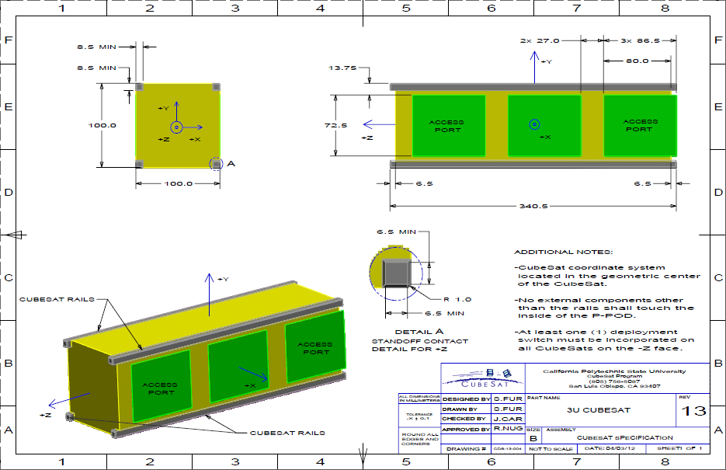

**Figure 1-1. Location of Remove Before Flight Pin Access Points**

1. **The CubeSat System Shall Incorporate a Deployment Switch**

This requirement comes from the CDS Document, Rev 12, Section 2.3.2. The purpose of the deployment switch is to completely turn off satellite power once in its actuated state. Because the verification of this requirement comes from repeated demonstrations during testing, this requirement falls under the Demo category.

1. **No Protrusion Shall Extend beyond 6.5 mm Normal to Any External Surface of Jade or Turquoise**
2. **No External Components Other than the CubeSat Rails of Jade and Turquoise may make Contact with the Deployer**
3. **The Deployer Shall not be Used to Secure Any CubeSat Deployables**
4. **The Center of Gravity of the total CubeSat System Shall be Located within a Sphere of 2 cm of the Geometric Center of the System**
5. **The Center of Gravity of Jade and Turquoise Shall be Located within a Sphere of 2 cm of their Geometric Center**
6. **The CubeSat System Coordinate System Shall be Defined As Specified in Figure 1-1**
7. **The Local Coordinate System of Jade and Turquoise Shall be Defined as Specified in Figure 1-1**
8. **The Ends of the Rails on the +Z/-Z Faces of the CubeSat System Shall have a Minimum Surface Area of 6.5 mm x 6.5 mm**

This requirement comes from the CDS Document, Rev 12, which determines the sizing of the “feet” that lie between any CubeSat and the ends of its deployer. Validation of this requirement will be completed through a measurement of relevant rail parameters prior to deployer integration. Hence, verification of this requirement falls under the Examine category.

1. **The +Y/-Y Faces of the CubeSat System Shall have a Length of 100 mm**

This requirement comes from the CDS Document, Rev 12, which states that the maximum width of a CubeSat system in the Y-axis direction is 100 mm. Validation of this requirement will be completed through a measurement of the width of the CubeSat system, as well as through a fit check of the system with the deployer that it will be integrated into. Hence, verification of this requirement falls under the Examine category.

1. **The +X/-X Faces of the CubeSat System Shall have a Length of 200 mm**

This requirement stems from the CDS Document, Rev 12, which states that the maximum width of a CubeSat system is 200 mm. Validation of this requirement will be completed through a measurement of the width of the CubeSat system, as well as through a fit check of the system with the deployer that it will be integrated into. Hence, verification of this requirement falls under the Examine category.

1. **The height of the CubeSat System Shall be 300 mm**

This requirement derives itself from the CDS Document, Rev 12, which states that the height of any CubeSat must be limited to 300 mm. Validation of this requirement will be completed through a measurement of the total height of the CubeSat system, as well as through a fit check of the system with the deployer that it will be integrated into. Hence, verification of this requirement falls under the Examine category.

1. **Jade and Turquoise Shall be Capable of Determining Relative Displacement between Each Other**

This requirement comes from the need to determine the relative distance between the two spacecraft as they separate for navigation, and more importantly, mission success purposes. This requirement will be imposed upon the Rascal payload, as its primary purpose will ultimately be to determine the relative position between Jade and Turquoise. This requirement will be satisfied by demonstrating this capability prior to integration into the launch vehicle, and will thus consist of a Demo.

1. **The CubeSat System Shall be Capable of Recording Relative Displacement Data between Jade and Turquoise**

This requirement stems from the necessity of understanding the relative displacement between Jade and Turquoise after particular mission events, such as Rendezvous and “Escape”, have already taken place, since it is unlikely that constant communication would be possible between the CubeSat system and the SSRL ground station for the entirety of each of these events. This will be satisfied by Demonstrating this capability prior to integration into the launch vehicle.

1. **Low Friction, 2D Testing of the CubeSat System Release Mechanism Shall be Conducted**

This requirement comes from the need of the Jade and Turquoise to separate in order to conduct the Rascal mission, thus falling under the SSRL requirement list. This will be verified through the used of the FRED (Frictionally Reduced Environment Dynamics) system, which consists of a flat platform through which a stream of air will be passed, as to reduce the friction between any object resting on its surface (Such as a Propulsion Unit), and FRED itself, allowing for a more accurate representation of Rascal’s on-orbit environment. Thus, this validation method falls under the Demo category.

1. **All Pressure Vessels Shall have a Factor of Safety of No Less Than 4**

This requirement stems from the CDS Document, Rev12, Section 2.1.4.1. This requirement will be validated in the design process of any pressure vessel that will be incorporated into the Rascal mission, which will involve analyses of the mechanics associated with the pressure vessel materials and geometry. Thus, the validation method for this requirement falls under the Analyze category.

1. **All CubeSat Components Shall be Rated to Operate within Temperature Range of at least -20⁰C to 70 ⁰C**

This requirement is set by Team Bravo's RFP, Section 1. The requirement was created to ensure that all components will survive the temperature range that the CubeSat system will encounter on orbit. To verify that this requirement has been met, an Analysis of the data sheets for each component shall be performed to check that the survival temperatures fall in this range. For those components that are developed at the SSRL, each component that is used in its assembly will be rated to operate within said range. Thus, the validation of this requirement falls under the Analyze category.

1. **Static Thrust Testing Shall be Performed with the Flight Version of All Pressure Vessels at a Pressure No Greater than 1x10-4 Torr Prior to CubeSat Integration**

This requirement is set by Environmental Testing Requirements. This requirement was created to ensure that the propulsion system will operate in vacuum environment. To verify that this requirement has been met, the propulsion system must pass a static thrust test with no anomalies in a vacuum chamber at a pressure no greater than 1x10-4 Torr. This data will be critical in determining the performance of a given propulsion design, and thus whether or not it will be able to meet all of the requirements laid out in this Requirements Verification document. If a design does not meet these requirements, it will be necessary to either change the design or re-evaluate the actual requirements. Thus, this requirement will be validated through Testing.

1. **All Pressure Vessels Must Pass Thermal Cycle Testing between Temperatures of -30 ⁰C and 70 ⁰C for at Least Two Cycles or for 10 Hours**

This requirement is set by Environmental Testing Requirements. The requirement was created to ensure the propulsion system will survive the temperatures that it will encounter while it is in orbit. The temperature profile that will be used was established by previous Educational Launch of Nanosatellites (ELaNa) missions to help validate the performance of CubeSat missions in space-like thermal environments. An illustration of this particular profile is shown in Figure 1-2 below. To verify that this requirement has been met, the propulsion system shall perform static thrusts before the thermal cycle, to establish that the system works before the test. Then a static thrust test shall occur at various points throughout the thermal cycle, with data being collected on the performance of the system for each thrust. Finally, a static test shall take place after the thermal cycle, as to check that the propulsion system still operates under normal conditions. Thus, the validation of this requirement falls under the Test category.



**Figure 1-2. Rascal Thermal Cycle Test Profile**

1. **Low Friction, 2-D Dynamic Thrust Testing Shall be Conducted with All Pressure Vessels**

This requirement stems from the necessity of having a detailed understanding of the propulsion system(s) that will be used to accomplish the Rascal mission. Without conducting base-line testing on any propulsion system developed for the mission, there would be no way of understanding how the CubeSat system would behave for a given system input in orbit or how long it would last upon reaching orbit, which could prove detrimental to mission success, hence the necessity of this requirement. Thus, this requirement will be verified with the FRED testing unit discussed in requirement RCL.PL.STR17, which will be used to model CubeSat system response to thruster inputs. Hence, the validations method for this requirement falls under the Test category.

1. **The CubeSat System Must Survive Random Vibration Testing Relative to the NASA GEVS Qualification Profile**

This requirement is set by the NASA document General Environmental Verification Standard for GSFC Flight Programs and Projects. The requirement was created to ensure the CubeSat system will survive the vibration environment of launch. The GEVS profile was created as a general vibration profile to cover as many vibration environments as possible, and is shown in Figure 1-3.

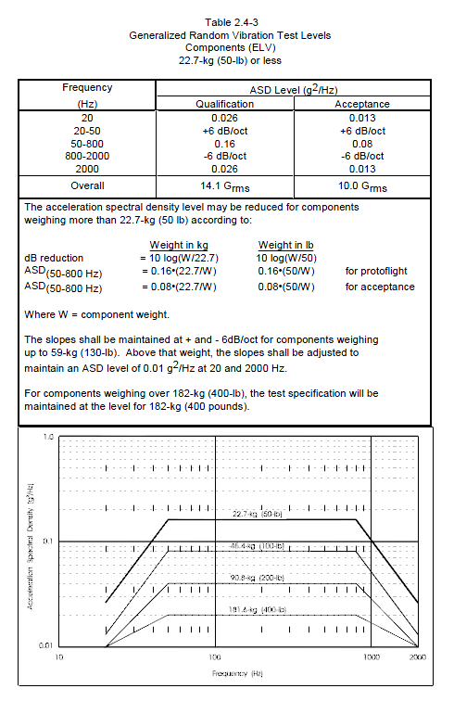

**Figure 1-3. NASA GEVS Random Vibration Profile**

To verify that this requirement has been met, the CubeSat System shall perform an abbreviated functional test to establish that all systems work before testing. A sine sweep shall be performed on before each axis of testing, as to establish the CubeSat System's natural response to vibration, thus allowing for failure assessment before the beginning of each axis of testing. Then the CubeSat system shall be shaken at the GEVS random vibration qualification profile for each axis. After the CubeSat system has been shaken on all three axes, a full functional test will be performed to check that all systems survived the process and are performing as normal. Thus, the validation method for this requirement falls under the Test category.

1. **The CubeSat System Shall be Subjected to a Temperature of 60 ⁰C at a Pressure No Greater than 1x10-4 Torr for a Minimum of 6 Hours**

This requirement exists to ensure the CubeSat system will accepted for launch vehicle integration, with its origin stemming from previous ELaNa missions that have required its execution before said integration*.* The requirement was created to ensure the CubeSat system does not release volatiles on orbit, which could damage nearby spacecraft. To verify this requirement has been met, an abbreviated functional test will be performed before bakeout to check that all the systems work. Then the CubeSat system shall undergo the bakeout at a temperature of 60 °C and a pressure no greater than 1x10-4 Torr for at least six hours. After the bakeout other abbreviated functional test shall be performed to check that all systems survived bakeout. This process ensures that if any volatile material were to be emitted in orbit that it instead is emitted during bakeout testing. Thus, the validation of this requirement falls under the Test category.

1. **The CubeSat System Shall be Able to Execute All Commands Associated with its Operation over RF**

This requirement was created to ensure the CubeSat system will be able to operate over Radio Frequencies (RF) before it is in orbit. The requirement needs to be met so the CubeSat system can perform functional tests. To verify this requirement has been met, a test will be performed to check that the CubeSat system can perform all the commands that would be needed of it over RF. Thus, the validation of this requirement falls under the Test category.

1. **The CubeSat System Shall be Able to Close a Link with the SSRL Ground Station from a Distance of at least 200 meters**

This requirement is created as to check that the CubeSat system can receive RF signals over a long distance. It has been required by the Air Force Research Laboratory before testing can take place there, thus leading to its requirement for the Rascal mission. To verify this requirement has been met, the CubeSat system will be taken to a distance of at least 200 meters from the SSRL Ground Station, at which point a functional test of the CubeSat system will take place through the use of the SSRL Ground Station. Along with allowing for environmental testing to take place at the Air Force Research Lab, this test improves confidence in the reliability of the Rascal communication system prior to launch. Hence, the validation of this requirement falls under the Test category.

1. **The CubeSat System Shall be able to Document the Functionality of Each of its Subsystems through the Running of a Full-Functional Test**

This requirement was created to ensure that each subsystem will perform as expected before undergoing environmental testing, and ultimately, launch. To verify this requirement has been met each subsystem in the CubeSat system must successfully execute any on-orbit command that could potentially be sent to it, as well as demonstrate key on-orbit operations.

# Post-Launch Ejection Requirements

1. **The CubeSat System Shall not Broadcast in RF Until Ejection +45 Minutes**

This requirement stems from past Launch Service Provider (LSP) requirements associated with previous CubeSat missions. Meeting this requirement can be demonstrated on the ground through the successful completion of a Day in the Life Test, which involves putting the CubeSat system through all of the steps associated with its integration and launch and documenting if it performed in the manner dictated by its operating system and Start-Up Sequence. Hence, validation of this requirement falls under the Demo category.

1. **The CubeSat System Shall not Release Deployables Until Ejection +45 Minutes**

Like requirement RCL.PLE.MOP1, this requirement stems from previous LSP requirements for CubeSat missions. It will be validated in the same way described in the same requirement and thus falls under the same category.

1. **The CubeSat System Shall Establish Communication Between Itself and the SSRL Ground Station**

This requirement stems from requirements laid out by the SSRL. The rationale behind this is that, in order to verify that the mission has been successfully executed, it is necessary to communicate with the CubeSat System while it is in orbit, as to downlink important relative displacement data, propulsion system pressures and temperatures, and any other important data that the success of the mission relies upon. This particular requirement involves successfully interpreting information stored in the CubeSat systems’ beacon stream, which could include temperatures, voltages, board states, pressures, etc. Beyond being able to interpret this information, no other tasks, such as data analysis or data uplink, are associated with this requirement. Hence, the validation of this requirement falls under the Demo category.

1. **The CubeSat System Shall Pass a Health Check Administered from the SSRL Ground Station**

This requirement derives from validating that each subsystem of the CubeSat system is in proper working order after delivery, integration, wait-time, and launch, and is thus considered an SSRL requirement. A Standard Health check would involve analyzing solar panel and battery voltages and temperatures, propulsion system pressures and temperatures, solar panel deployment, payload checkout, etc, and verifying that the results obtained fall within a specific range that was established from ground testing and demonstrations (As Discussed in Requirements RCL.PL.TST1 through RCL.PL.TST5). If any part of the CubeSat system failed to pass its respective health check, mission execution would be delayed until the problem causing the anomaly was found and resolved. Once all anomalies are accounted for, the CubeSat system would be considered to enter Stage 3 of its mission life. With this in mind, validation of this requirement falls under the Analyze category.

# Separation and Stabilization Requirements

The Separation and Stabilization portion of the Rascal Mission will commence after the CubeSat system has fully passed the checkout sequence discussed in requirement RCL.PLE.MOP4. It will be initiated by a command from the SSRL Ground Station and will consist of the separation of Jade and Turquoise, stabilization of each satellites slew rates, and a checkout of the relative displacement calculation methods present on the CubeSat system. It will end when confidence in the relative displacement checkout has been achieved.

1. **Jade and Turquoise Shall be Capable of Separating from One Another with a Relative Velocity of No Greater than 5 cm/s**

This requirement stems from the need to mitigate the chances of Jade and Turquoise drifting too far apart upon initial separation from each other. Based on past mission data, such as that of SNAP-1 and Dart, it is highly critical that Jade and Turquoise meet this requirement, as the relative distances between them can become highly unpredictable for relatively small initial relative velocities, which could easily lead to full mission failure.

A value of 5 cm/s was selected based on an orbital analysis of Jade and Turquoise’s motion relative to each other for various initial relative velocities. An example of these relative motions for the 10 cm/s and 50 cm/s cases is shown in Figures 1-4 through 1-5.

Magnitude of Relative Displacement 5 cm-s Initial Relative Velocity.tif

**Figure 1-4. Relative Displacement Magnitude for 10 cm/s Initial Relative Velocity**

**Magnitude of Relative Displacement 50 cm-s Initial Relative Velocity.tif**

**Figure 1-5. Relative Displacement Magnitude for 50 cm/s Initial Relative Velocity**

Based on the results obtained from this analysis, the highest initial relative velocity that kept Jade and Turquoise within a 50 meter range of each other for their entire orbits was that of 5 cm/s. The validation of this requirement will be based on orbital mechanics calculations made before launch, as well as actual mission data after the launch. Hence, the validation method for this requirement falls under the Analyze category.

1. **Jade and Turquoise Shall Achieve a Local Slew Rate of Less than 1 deg/s**

The rationale for this requirement stems from slew rate data collected from previous CubeSat Missions, as discussed in *Surry Space Centre Control Techniques for Aerospace Systems* and *Attitude Control for Small Satellites Using Control Moment Gyros*, each of which refer to slew rates of 1 deg/s as being attainable for CubeSat sized spacecraft. Hence, in order to determine the local stability of Jade and Turquoise, it is reasonable to attach said value to them. Validation of this requirement will be made through an analysis of rotation data downlinked from each spacecraft. Hence, the validation method of this requirement falls under the Analyze category.

1. **Jade and Turquoise Shall Record Relative Displacement Data Between Each Other at Least Once a Second**

This requirement derives from the need to know with certainty the relative displacement between Jade and Turquoise throughout the course of the mission, thus allowing for the validation of the completion of the mission requirement discussed in the Sections 4-6. Without this data, it would be entirely impossible to verify that the mission, as it is laid out in the Team Bravo RFP, was ever successfully completed. This requirement will be verified by downlinking the relative displacement of Jade and Turquoise for several passes after initial separation, as to verify that said data is being recorded continuously. Hence, the validation of this requirement falls under the Analyze category.

# Stationkeeping Requirements

The stationkeeping stage will consist of performing orbital maneuvers that maintain a relative displacement between Jade and Turquoise of less than 75 meters, as specified by the Team Bravo RFP. The stationkeeping process will be initiated by a command form the SSRL ground station and will take place autonomously thereafter. This stage will end only after verification of its success has been made.

1. **Jade and Turquoise Shall be Able to Stationkeep within a 10-75 meter Sphere of Each Other for at Least 5 Orbits**

This requirement stems directly from the Team Bravo RFP, which defined Stationkeeping in the manner described above. This requirement will be initiated by a command from the SSRL Ground Station, at which point it will be accomplished autonomously. Validation of this requirement will then come after at least five orbits have passed, at which point relative displacement data will be downlinked from the CubeSat system and will be analyzed to verify that Jade and Turquoise stayed within a 10-75 meter sphere of each other. Thus, this validation method falls under the Analyze category.

# “Escape” Requirements

The next stage of the Rascal mission consists of Jade and Turquoise performing an “Escape” maneuver relative to each other, as defined in the Team Bravo RFP. Thus, this stage consists of either Jade or Turquoise receiving a command to perform an orbital maneuver relative to the other that increases the relative displacement between the two satellites over a short period of time. This stage of the mission will conclude when verification of each of the requirements associated with it has been made.

1. **Jade and Turquoise Shall be Able to Perform an “Escape” Maneuver that Increases the Relative Displacement Between Each Other to at Least 100 Meters within 1 Orbit**

This requirement is derived directly from the Team Bravo Request for Proposal. It will involve sending a command to begin the “Escape” sequence, at which point the relative displacement between each satellite will increase quickly for one orbit, but then become stable upon reaching more than 100 meters. This requirement will be validated in the same manner discussed in Section 4, in that all relative displacement data related to the “Escape” sequence will be downlinked and analyzed, as to verify that Jade and Turquoise achieved the requirement goals. Thus, the validation of this requirement falls under the Analyze category.

# Rendezvous Requirements

The final stage of the Rascal mission consists of rendezvous, as defined in the Team Bravo RFP. This stage will commence upon either Jade or Turquoise receiving a command from the ground at the completion of the “Escape” stage to reduce the relative displacement between each other and maintain a small relative displacement for a number of orbits. This stage will be considered complete when it has been verified that all of the requirements associated with it have been met.

1. **Jade and Turquoise Shall be Able to Perform a Rendezvous by Decreasing the Relative Displacement Between Each Other to Within 50 meters for at Least 5 Orbits**

This requirement stems directly from the Team Bravo RFP. To meet it, rendezvous will be initiated at the end of the “Escape” sequence discussed in Section 5, at which point the relative displacement between Jade and Turquoise will be decreased. Once Jade and Turquoise are within a 50 meter sphere of each other for at least 5 orbits, displacement data for the entire rendezvous sequence will be downlinked and analyzed as to verify that Jade and Turquoise each met the requirement. Thus, the validation of this requirement falls under the Analyze category.